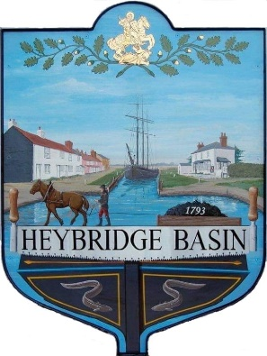
HEYBRIDGE BASIN PARISH COUNCIL
Complaints Policy

Heybridge Basin Parish Council is committed to providing a quality service for the benefit of the people who live or work in its area or are visitors to the parish. If you are dissatisfied with the standard of service you have received from the Council or are unhappy about an action or lack of action by this Council, this Complaints Procedure sets out how you may complain to the Council and how we shall try to resolve your complaint.

This Complaints Procedure applies to complaints about council administration and procedures and may include complaints about how the council has dealt with your concerns.

This Complaints Procedure does not apply to:

- Complaints by one council employee against another council employee, or between a council employee and the council as an employer. These matters are dealt with under the council’s disciplinary and grievance procedure.
- Complaints against Councilors. Complaints against councilors are covered by the Code of Conduct for Members adopted by the Council in July 2022 and, if a complaint against a councilor is received by the Council, it will be referred to the Monitoring Officer at Maldon District Council. Further information on the process of dealing with complaints against councilors may be obtained from the Monitoring Officer of Maldon District Council.

The appropriate time for influencing Council decision-making is by raising your concerns before the Council debates and votes on a matter. You may be do this by writing to the Council in advance of the meeting at which the item is to be discussed. There may also be the opportunity to raise your concerns in the public participation section of Council meetings. If you are unhappy with a Council decision, you may raise your concerns with the Council, but Standing Orders prevent the Council from re-opening the issues for 6 months from the date of the decision, unless there are exceptional grounds to consider this necessary and the special process set out in the Standing Orders is followed
Wherever possible, the Clerk will try to resolve your complaint immediately. If this is not possible, the Clerk will normally try to acknowledge your complaint within five working days.

You may make your complaint about the council’s procedures or administration to the Clerk. You may do this by phone, or by writing to or emailing the Clerk. The contact details are set out below.

If you do not wish to report your complaint to the Clerk, you may make your complaint directly to the Chair of the Council who will report your complaint to the Council.

The Clerk or the Council will investigate each complaint, obtaining further information as necessary from you and/or members of the Council.

The Clerk or the Chair of the Council will notify you within 20 working days of the outcome of your complaint and of what action (if any) the Council proposes to take as a result of your complaint. In exceptional cases the twenty working days timescale may have to be extended. If it is, you will be kept informed.

If you are dissatisfied with the response to your complaint, you may ask for your complaint to be referred to full Council and (usually within eight weeks) you will be notified in writing of the outcome of the review of your original complaint.
Contacts:
The Clerk of Heybridge Basin Parish Council
Address: HBPC, PO Box 13224, Maldon, CM9 9FW
Telephone: 07526 474604
Email: Clerk@heybridgebasinpc.org.uk

The Chair of Heybridge Basin Parish Council
Address: HBPC, PO Box 13224, Maldon, CM9 9FW
Email: martynhodges@heybridgebasinpc.org.uk

Reviewed and approved: | Minute:
1st November 2022 | 22/128 a
16th May 2023 | 23/14 a

